LifeCycle Criteria

Lifecycle Event – Voyager Employee Pre-Hire

Event Configuration
Attribute | Value
Name | Voyager Employee Pre-Hire
Type | Create

Event Criteria
The lifecycle event is triggered when the following conditions are satisfied:
- Assignment Status Type Code must be equal to "Active - Payroll Eligible".
- Employee Type must be equal to "P" or "E".
- Assignment Action must be equal to one of the following values:
  - HIRE
  - ADD_PEN_WKR
  - Add Pending Worker

Lifecycle Event – Voyager Employee Pre-Hire - Pending PreHire

Event Configuration
Attribute | Value
Name | Voyager Employee Pre-Hire - Pending PreHire
Type | Rule

Event Rule:
Check the HIRE_DATE must be equal to next 365 days or currentDate.

Event Criteria
The lifecycle event is triggered when the following conditions are satisfied:
- Joiner Status must be equal to “Pending PreHire Associate”.
- Assignment Status Type Code must be equal to "Active - Payroll Eligible".
- Employee Type must be equal to "P" or "E".
- Assignment Action must be equal to one of the following values:
  - HIRE
  - ADD_PEN_WKR
  - Add Pending Worker

Flow Chart
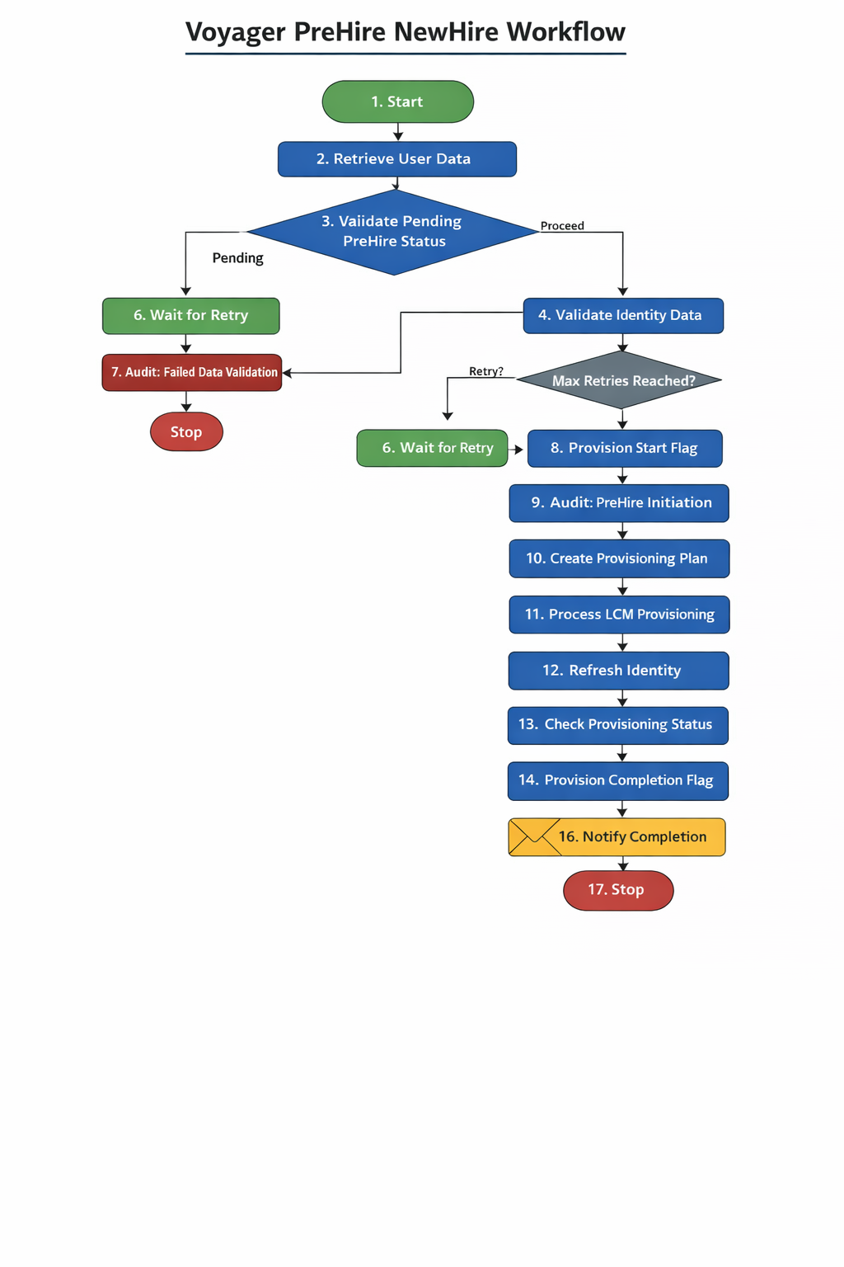

Step Summary

Voyager PreHire NewHire Workflow – Step Summary
Step No. | Workflow Step | Description
1 | Start | Initiates the workflow when the Voyager Employee Pre-Hire lifecycle event is triggered.
2 | Retrieve User Data | Retrieves identity attributes, determines workflow classification (Associate or NEP), collects manager details, and stores required variables in the workflow case.
3 | Validate Pending PreHire Status | Evaluates the hire date and worker type to determine whether the identity should be placed in a Pending PreHire status.
4 | Validate Identity Data | Validates that all required identity attributes are available before provisioning begins to prevent failures.
5 | Check Retry Count | Ensures the workflow does not enter an infinite loop by limiting validation retries to a maximum of three attempts.
6 | Data Validation Failed – Wait for Next Retry | If required data is missing, the workflow pauses and waits until the configured retry threshold is reached before attempting validation again.
7 | Audit Event for Failed Data Validation | Creates an audit event and stops the workflow if required attributes remain missing after all retry attempts.
8 | Provision Voyager Start Flag | Updates the identity attribute joinerStatus to indicate that the PreHire provisioning process has started.
9 | Audit Event – PreHire Initiation | Records an audit event indicating the initiation of the PreHire Associate Event.
10 | Create Birthright Provisioning Plan | Generates a provisioning plan to create required accounts such as Active Directory and Oracle ERP Cloud, including dynamic AD domain mapping.
11 | Process LCM Provisioning | Executes the provisioning plan through the LCM Provisioning Workflow and creates a ServiceNow incident if errors or warnings occur.
12 | Refresh Identity | Runs an Identity Refresh to synchronize newly provisioned account attributes back to SailPoint.
13 | Check Provisioning Status | Reviews the provisioning results and stores any application-specific errors or warnings.
14 | Provision Voyager Completion Flag | Updates the identity attribute joinerStatus to indicate that provisioning has been completed.
15 | Audit Event – PreHire Completion | Logs an audit event to record the successful completion of the PreHire Associate Event.
16 | Notify Completion | Sends a PreHire completion notification to the user's manager, including any provisioning issues if present.
17 | Stop | Ends the workflow after completing provisioning, auditing, and notification activities.

Workflow Description

Workflow:

Name : Voyager PreHire NewHire Workflow

1. Start
The workflow is initiated when the Voyager Employee Pre-Hire lifecycle event is triggered.

2. Retrieve User Data
This step retrieves identity attributes from SailPoint and prepares the required variables for subsequent workflow processing.

Identity Data Retrieval
The following key attributes are retrieved and stored as workflow variables:
- workerType
- hireDate
- departmentNumber
- personNumber

Workflow Classification
The workflow determines the process flow based on the workerType:
- Associate Flow
  - If workerType = "P" or "E"
  - Event classified as "PreHire Associate Event"
- NEP Flow
  - For all other worker types
  - Event classified as "NewHire NEP Event"

Manager Information Retrieval
The workflow retrieves the following manager information:
- Manager display name
- Manager employee ID

Manager Email Fallback
- The manager’s email address is retrieved.
- If no email exists, the workflow defaults to IAMOpsTeamQueue.

Variable Mapping
All retrieved and calculated values (such as subject lines, event names, flow types, and manager details) are stored in the Workflow Case for use in later workflow steps.

3. Validate Pending PreHire Status
This step evaluates whether the user should be placed in a pending pre-hire state based on the hire date and worker classification.

Associate Pending Logic
- If the hireDate is in the future and workerType is "P" or "E":
  - Identity status is updated to "Pending PreHire Associate".

Contractor / NEP Pending Logic
- If the hireDate is not today or in the past and workerType is "C":
  - Identity status is updated to "Pending NewHire".

4. Validate Identity Data
This step validates the presence of required identity attributes before provisioning begins.
The following attributes are validated and stored in a validation map:
- workerType
- assignmentActionCode
- assignmentStatusTypeCode
- hireDate
- firstName
- lastName
- market
- personNumber
- managerPersonNumber
- managerEmail
This validation prevents provisioning failures caused by missing or incomplete data.

5. Check Retry Count
This step prevents the workflow from entering an infinite retry loop when required data is missing.

Threshold Validation
- The workflow checks the current retry count against the configured limit of 3 retries.

Retry Decision
- If the retry limit has not been reached, the workflow sets isRetryNeeded = true to allow another validation attempt.
- If the retry limit has been exceeded, the workflow sets isRetryNeeded = false and escalates the failure.

Retry Counter Update
- The variable validationMaxRetries is incremented by 1 during each validation attempt.

6. Data Validation Failed – Wait for Next Retry
If required data is missing, the workflow enters a waiting state.
- The workflow pauses execution.
- It resumes once the configured wait threshold provisioningRetryThreshold is reached(currently the threshold is set as 5 mins but can be increased as per the requirement).
- After the wait period, the validation step is executed again.

7. Audit Event for Failed Data Validation
If required attributes remain missing after all retry attempts, an audit event is generated.
Audit Event Name:
Data Validation Issue - PreHire Associate Event
The workflow creates an audit event and terminates if any of the following attributes are null or blank:
- workerType
- assignmentActionCode
- assignmentStatusTypeCode
- hireDate
- firstName
- lastName
- market
- personNumber
- managerPersonNumber
- managerEmail

8. Provision Voyager Start Flag
The workflow updates the identity lifecycle flag to indicate the start of the pre-hire provisioning process.
Attribute | Value
joinerStatus | PreHire Associate Initiated

9. Audit Event – PreHire Process Initiation
An audit event is generated to record the start of the provisioning process.
Audit Event Name:
Initiated - PreHire Associate Event

10. Create Birthright Provisioning Plan
This step constructs the Provisioning Plan required to create user accounts in downstream systems.

Email Initialization
A helper function updateEmail is executed to ensure that the identity has a valid email address before account provisioning begins.

Dynamic Active Directory Application Lookup
The workflow dynamically determines the correct Active Directory domain using the following configuration:
- Custom Object: Ascension-Custom-AD-DomainMapping
Process flow:
- The user's domain attribute is retrieved.
- The workflow searches the DomainOUMapping key within the custom object.
- The correct target AD application name is identified based on the mapping.

Account Request Generation

Active Directory
An AccountRequest is created for the mapped Active Directory application.
When the account creation request is executed:
- The Create Provisioning Policy is triggered.
- The rule "Voyager Dynamic Field Value Rule" generates required account attributes such as:
  - sAMAccountName
  - Account DN
  - mail
  - userPrincipalName

Oracle ERP
An additional AccountRequest is automatically generated for:
- Oracle ERP Cloud
This access is assigned as part of the standard birthright provisioning.

Validation and Error Handling
If any of the following conditions occur:
- The custom mapping object is missing.
- The user's domain cannot be found in the mapping.
The workflow sets an error flag:
acReqOK = false
The workflow also attaches the following to the provisioning plan:
- Identity object
- identityName as the Native Identity

11. Process LCM Provisioning
The generated provisioning plan is executed using the LCM Provisioning Workflow.
After execution:
- The ProvisioningResult of the ProvisioningProject is evaluated.
- If errors or warnings are detected:
  - A ServiceNow Incident Ticket is automatically created.
  - The ticket includes request details and error information.

12. Refresh Identity
The workflow executes an Identity Refresh operation to synchronize target system attributes back into SailPoint.
This ensures that all target-mapped attributes are updated.

13. Check Provisioning Status
This step reviews the ProvisioningProject result.
- Any errors or warnings encountered during provisioning are captured.
- These issues are stored in an application-specific status map for reporting and notification purposes.

14. Provision Voyager Completion Flag
The workflow updates the identity lifecycle attribute to mark the completion of provisioning.
Attribute | Value
joinerStatus | PreHire Associate Completed

15. Audit Event – PreHire Process Completion
An audit event is created to record the completion of the pre-hire process.
Audit Event Name:
Completed - PreHire Associate Event

16. Notify Completion
A Pre-Hire Completion Notification is sent to the user's manager.
The notification includes:
- Confirmation of account provisioning completion
- Details of any errors or warnings identified during the Check Provisioning Status step

17. Stop
The workflow ends after completing all provisioning, auditing, and notification activities.

Credential Notification Process

AD After Provisioning Rule
Rule Name:
Voyager AD-DS After Rule for Credentials Send

Purpose
This rule securely distributes the user's credentials after successful Active Directory account provisioning.

Process
- After the AD account is successfully created, the rule is triggered.
- The generated credentials are securely retrieved.
- An email notification containing the credentials is sent to the user’s manager.
This ensures secure delivery of login information while maintaining compliance with access management policies.

